CASE STUDY 3

IBM CLOUD

Q.1 What do you understand about IBM cloud? What are major services offered by IBM Cloud? Elaborate.

Ans- IBM Cloud is a platform that helps developers build and run modern apps and services. It provides developers with instant access to the compute and services they need to launch quickly, iterate continuously and scale with success

The IBM Cloud brand includes infrastructure as a service, software as a service and platform as a service offered through public, private and hybrid cloud delivery models

With IBM Cloud IaaS, organizations can deploy and access virtualized IT resources -- such as compute power, storage and networking -- over the internet. For compute, organizations can choose between bare-metal or virtual servers.

With IBM Cloud PaaS -- which is based on the open source cloud platform [Cloud Foundry](https://searchcloudcomputing.techtarget.com/definition/Cloud-Foundry) -- developers can use IBM services to create, manage, run and deploy various types of applications for the public cloud, as well as for local or on-premises environments. IBM Cloud supports various programming languages, such as Java, Node.js, PHP and Python and extends to support other languages.

Software as a service -- Cloud-based applications that run on distant computers “in the cloud” that are owned and operated by others and that connect to users’ computers via the internet and (usually) a web browser.

The IBM Cloud Catalog lists over 170 services across categories, including:

1. Network -- Provides cloud networking services, such as a load balancer, a content delivery network (CDN), virtual private network (VPN) tunnels and firewalls;
2. Storage -- Offers object, block and file storage for cloud data;
3. Management -- Provides tools to manage and monitor cloud deployments, such as those for log analysis, automation and Infrastructure as Code (IaC);
4. Security -- Includes services for activity tracking, identity and access management and authentication;
5. Data management -- Provides SQL and NoSQL databases, as well as data querying and migration tools;
6. Analytics -- Offers data science tools such as Apache Spark, Apache Hadoop and IBM Watson Machine Learning, as well as analytics services for streaming data;
7. Artificial Intelligence (AI) -- Uses IBM Watson to deliver services such as machine learning, natural language processing and visual recognition;
8. Internet of things (IoT) -- Includes the IBM IoT Platform, which provides services that connect and manage IoT devices, and analyzes the data they produce;
9. Mobile -- Enables a development team to build and monitor mobile applications and their back-end components;
10. Blockchain -- Provides IBM's Blockchain Platform, a software-as-a-service offering to develop apps, enforce governance and monitor a Blockchain network;

Q.2 What is container concept in Cloud computing? Explain about IBM Bluemix Container Service.

Ans- Containers are an executable unit of software in which application code is packaged, along with its libraries and dependencies, in common ways so that it can be run anywhere, whether it be on desktop, traditional IT, or the cloud.

To do this, containers take advantage of a form of operating system (OS) virtualization in which features of the OS leveraged to both isolate processes and control the amount of CPU, memory, and disk that those processes have access to.

Containers are small, fast, and portable because unlike a virtual machine, containers do not need include a guest OS in every instance and can, instead, simply leverage the features and resources of the host OS.

The primary advantage of containers, especially compared to a VM, is providing a level of abstraction that makes them lightweight and portable.

* Lightweight: Containers share the machine OS kernel, eliminating the need for a full OS instance per application and making container files small and easy on resources.
* Portable and platform independent: Containers carry all their dependencies with them, meaning that software can be written once and then run without needing to be re-configured across laptops, cloud, and on-premises computing environments.

IBM Bluemix, rebranded IBM Cloud in 2017, is a cloud Platform as a service (PaaS) developed by IBM. It supports several programming languages and services as well as integrated DevOps to build, run, deploy and manage applications on the cloud. Bluemix is based on Cloud Foundry open technology and runs on SoftLayer infrastructure. Bluemix supports several programming languages including Java, Node.js, Go, PHP, Swift, Python, Ruby Sinatra, Ruby on Rails and can be extended to support other languages such as Scala through the use of build packs.

Q.3 Explain the concept of Cloud Foundry in IBM Cloud.

Ans- Cloud Foundry is an open source, platform-as-a-service (PaaS) on IBM Cloud that enables you to deploy and scale apps without managing servers. It is the premier industry standard Platform-as-a-Service (PaaS), that ensures the fastest, easiest, and most reliable deployment of cloud-native applications

Cloud Foundry architecture in IBM Cloud --

In general, you don't have to worry about the operating system and infrastructure layers when running apps on IBM Cloud in Cloud Foundry. Layers such as root filesystems and middleware components are abstracted so that you can focus on your application code. However, you can learn more about these layers if you need specifics on where your app is running.

As a developer, you can interact with the IBM Cloud infrastructure by using a browser-based user interface. You can also use a Cloud Foundry command line interface, called cf, to deploy web apps.

Clients--which can be mobile apps, apps that run externally, apps that are built on IBM Cloud, or developers that are using browsers--interact with the IBM Cloud-hosted apps. Clients use REST or HTTP APIs to route requests through IBM Cloud to one of the app instances or the composite services.

The following figure shows the high-level Cloud Foundry architecture on IBM Cloud.

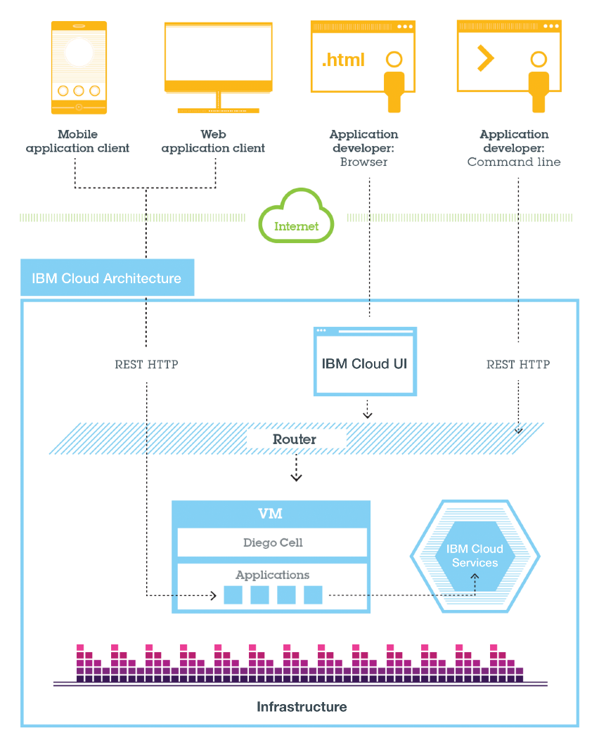

You can deploy your apps to different IBM Cloud regions, for latency or security considerations. You can choose to deploy either to one region or across multiple regions.

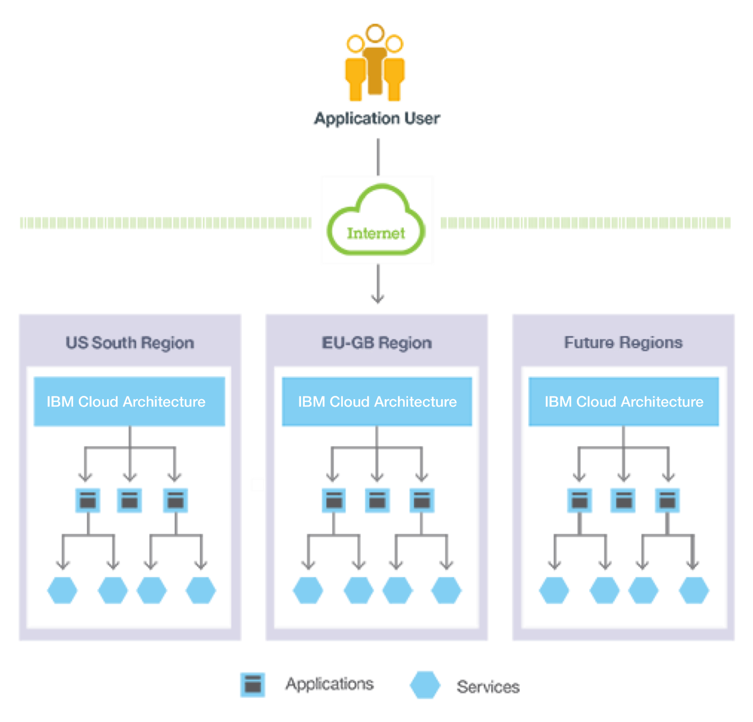

Q.4 What is Kubernetes Service in IBM Cloud? Discuss its working mechanism.

Ans- IBM Cloud Kubernetes Service is a managed Kubernetes offering to create your own Kubernetes cluster of compute hosts to deploy and manage containerized apps on IBM Cloud. As a certified Kubernetes provider, IBM Cloud Kubernetes Service provides intelligent scheduling, self-healing, horizontal scaling, service discovery and load balancing, automated rollouts and rollbacks, and secret and configuration management for your apps. Combined with an intuitive user experience, built-in security and isolation, and advanced tools to secure, manage, and monitor your cluster workloads, you can rapidly deliver highly available and secure containerized apps in the public cloud.

Key features of our Kubernetes Service-

1. Native Kubernetes Experience

Use the tools and APIs you already know for a single, consistent experience, even when working across different cloud infrastructures.

1. Secure Clusters

IBM provides security features to protect your cluster infrastructure, isolate your compute resources, and ensure security compliance in your container deployments.

1. Self-healing Containers

Configure a custom Kubernetes cluster that auto-scales and recovers containers based on defined policies.

1. Logging and Monitoring

Use the built-in logging and metrics service to monitor the performance of both your clusters and containers.

1. Intelligent Scheduling

Kubernetes automatically deploys containers on compute hosts according to the available resources across the cluster.

IBM Cloud Kubernetes Service creates a cluster of compute hosts and deploys highly available containers. A Kubernetes cluster lets you securely manage the resources that you need to quickly deploy, update, and scale applications. Clusters serve as the basis of the Kubernetes architecture. You can think of clusters as building blocks, and each Kubernetes cluster consists of at least one master node and multiple worker nodes. The master node controls and monitors worker nodes and all Kubernetes resources contained in a cluster. The master node runs a scheduler service that decides where apps are deployed based on deployment requirements and available capacity. Each worker node is a compute host that deploys, runs, and manages containerized apps. Worker nodes use tools to manage containers, such as Docker. Scripts specify container configuration and define the Kubernetes resources needed to run an application, including persistent storage, services, and annotations.

Q.5 What are the pricing schemes for computing resources in IBM Cloud? Make a list of pricing schemes and computing facilities.

Ans- Pricing Schemes -

A. Fixed Pricing

Each service provider defines price for resources that could be prohibitive and thus lead to a reduced customer base and decrease in revenue and profits. Fixed pricing includes pricing mechanism as pay-per-use pricing, subscription and list price / menu price.

B. Dynamic Pricing

The price is calculated based on pricing mechanism whenever there is a request. In some cases, the price of the resources is determined according to demand and supply. As compared to fixed prices, the dynamic pricing that reflects the real-time supply demand relationship represents a more promising charge strategy that can better exploit user payment potentials and thus larger profit gains at the cloud provider.

C. Market-Dependent Pricing

Customer pays depending on the real-time market conditions and constraints. This schemes includes:

Bargaining -- the price is determined on the basis of the relationship of the parties involved.

Yield Management -- the best pricing policy for optimizing profits is calculated based on real-time modeling and forecasting of demand behavior.

Auction – is a negotiation mechanism which allows both parties to communicate and to agree on the offer. The price is set as buyers bid in increasing increments of price.

Q.6 Discuss about features and working mechanism of IBM Watson for Natural language processing, visual recognition and machine learning.

Ans- IBM Watson Natural Language Understanding-

With IBM Watson Natural Language Understanding, developers can analyze semantic features of text input, including categories, concepts, emotion, entities, keywords, metadata, relations, semantic roles, and sentiment.

Features:

Send requests to the API with text, HTML, or a public URL, and specify one or more of the following features to analyze:

1. Categories -

Categorize your content using a five-level classification hierarchy.

1. Concepts -

Identify high-level concepts that aren't necessarily directly referenced in the text.

1. Emotions -

Analyze emotion conveyed by specific target phrases or by the document as a whole.

1. Entities -

Find people, places, events, and other types of entities mentioned in your content.

1. Keywords -

Search your content for relevant keywords.

1. Sentiment -

Analyze the sentiment toward specific target phrases and the sentiment of the document as a whole.

IBM Watson Visual Recognition --

The IBM Watson Visual Recognition service uses deep learning algorithms to analyze images for scenes, objects, and other content. The response includes keywords that provide information about the content.

The following image shows the process of creating and using Visual Recognition:

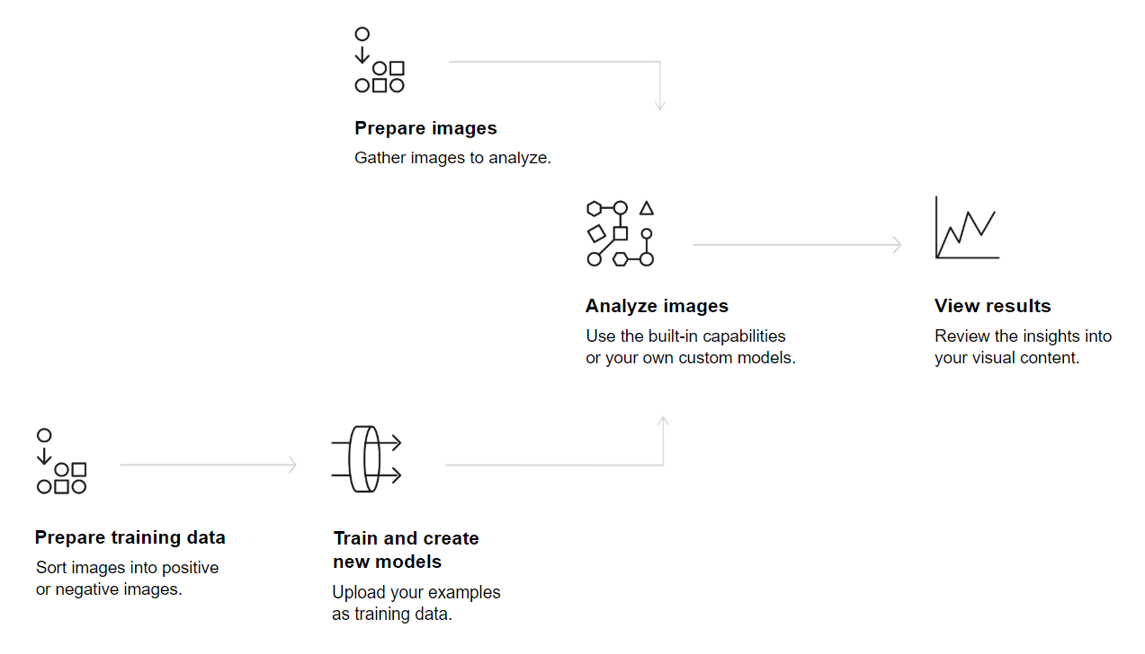

IBM Watson Visual Recognition Features-

1. Classify virtually any visual content -

Visual Recognition understands the contents of images. Analyze images for scenes, objects, faces, colors, food, and other subjects that can give you insights into your visual content.

1. Create your own classifiers -

Create and train your custom image classifiers using your own image collections.

1. Broad industry use cases -

Use cases include manufacturing, visual auditing, insurance, social listening, social commerce, retail and education.

IBM Watson Machine Learning -

IBM Watson Machine Learning is a full-service Bluemix offering that makes it easy for data scientists and developers to work together to integrate predictive analytics with their applications. Bluemix enables organizations and developers to quickly and easily create, deploy, and manage applications on the cloud.The focus of IBM Watson Machine Learning on Bluemix service is deployment. IBM SPSS Modeler or IBM Data Science Experience is required to build models. IBM SPSS Modeler is a powerful, versatile data mining workbench that helps you build predictive models quickly and intuitively, without programming. Data Science Experience enables you to analyze data using RStudio, Jupyter, and Python in a configured, collaborative environment that includes IBM value-adds, such as managed Spark and IBM Watson Machine Learning.

IBM Watson Machine Learning features -

1. Push algorithms and analytics to data

Decentralize and distribute your model training by harnessing Apache Spark to train machine learning and deep learning models on structured and unstructured data—whether it resides in relational databases, Hadoop and object storage.

1. Deploy and manage models

Manage and govern the AI and machine learning lifecycle from end to end, building portable models that can be deployed on cloud or on premises. Import models from other data science tools, and continuously train and deploy them as services, apps or scripts for a wide range of platforms and tools.

Q.7 Prepare a comparative chart among EC2, Microsoft Azure, Google Cloud and IBM Cloud based on at least 10 common features.

Ans- 